(Approx. 400 words)

Open Source Lab
Linux Mint 19.3
Author: Cal Esneault, Former President and leader of many Open Source Workshops & SIGs, Cajun Clickers Computer Club
January 2020 issue, Cajun Clickers Computer News
www.clickers.org
tsa70785 (at) gmail.com

Linux Mint is a distribution based on Ubuntu LTS versions. The latest series is the Mint 19.x family (based on Ubuntu 18.04 LTS). There are three desktop choices: Cinnamon, Mate, and XFCE. Recently, Mint 19.3 was released. Below is a list of the 19.x series.
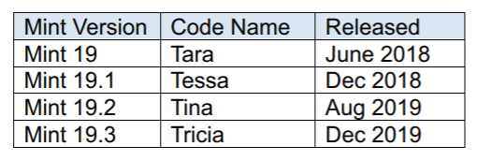
It is possible to upgrade directly to Mint 19.3 from any previous 19.x versions. These "in-place" upgrades do not affect personal files or bookmarks. As usual, only software maintained by Mint itself is changed for a "point release."
I was running Mint 19.2 (Cinnamon). As part of the normal updates, I received notice to refresh the update manager itself. After this, I users if they are missing a language package, a multimedia codec, etc. It also has a good system description and record of any system crashes (see below). 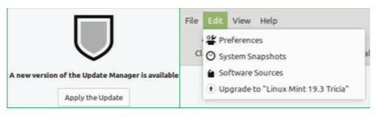
Linux Mint has focused on making recovery from any regressions during the upgrade as easy as possible. It is recommended that users precede upgrade with a "Timeshift" session for back-up and to read the installation notes. In this release, they go a step further by introducing the "System Reports" tool. It alerts users if they are missing a language package, a multimedia codec, etc. It also has a good system description and record of any system crashes (see below).
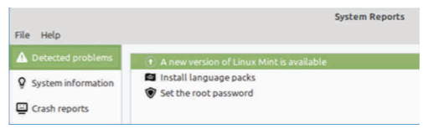
Celluloid, gnote, drawing, and neofetch were added to Linux Mint 19.3 as future defaults. For in-place upgrades, you have to do this manually (note: they are present in the iso download if you do a fresh install). Celluloid is a replacement for Xplayer (Celluloid is more efficient for playing movies on your system).
Gnote is a replacement for Tomboy (not much difference here). Drawing is Gnome-Paint renamed (a simple bit-map editing program).
Neofetch is a command line tool that can “fetch” all sorts of information about your system, from the Linux kernel version number to how long it’s been running (“uptime”). See a short screenshot of neofetch below.
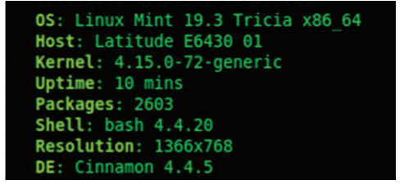
Mint appears to be backing-off from having so many in-house “Xapps.” Mint 19.2 is a refined version of Linux Mint and is recommended for current users. Upgrade here is a minor event but look for major changes when shifting to Mint 20 next year.

